**EXP NO 25. Database as a Service (DaaS) create and configure a new VM Image in any Public Cloud Service Provider using Azure.**

**AIM**: DATABASE AS A SERVICE (DAAS) CREATE AND CONFIGURE A NEW VM IMAGE IN ANY PUBLIC CLOUD SERVICE PROVIDER USING AZURE

**PROCEDURE:**

STEP1: GOTO AZURE AND GOTO SQLDATABASE.

STEP 02: Now Create a Sql Databse

STEP3: SELECT THE RESOURCE GROUPAND ENTER THE SERVERNAMETHATAPPLICABLE.

STEP4: IN NETWORKING SELECT ALLOW AZURE SERVICES AND

RESOURCES TO ACCESS THIS SERVER.

STEP5: IN ADDITIONAL SETTINGS SELECT SAMPLE.

STEP6:AND THE SQL DATABASE IS DEPLOYED

TEP7: NOW GOTO QUERY EDITOR.

STEP8:NOWAGAIN LOGIN TO THE SQLDATADATABASE

STEP9: OUR TABLES WILL SHOWN AND TYPE THE QUERY TO EXCUTED.

**IMPLEMENTATION:**

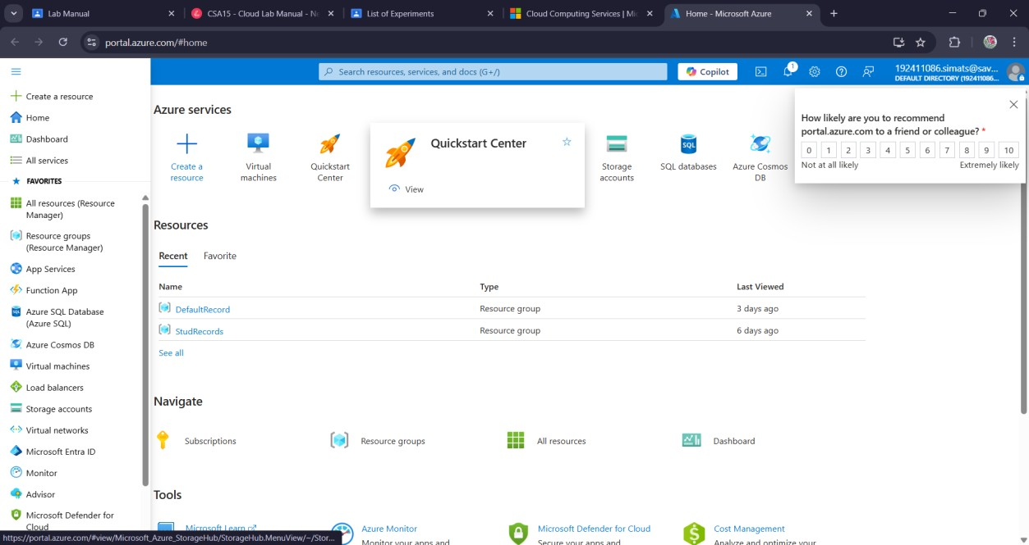

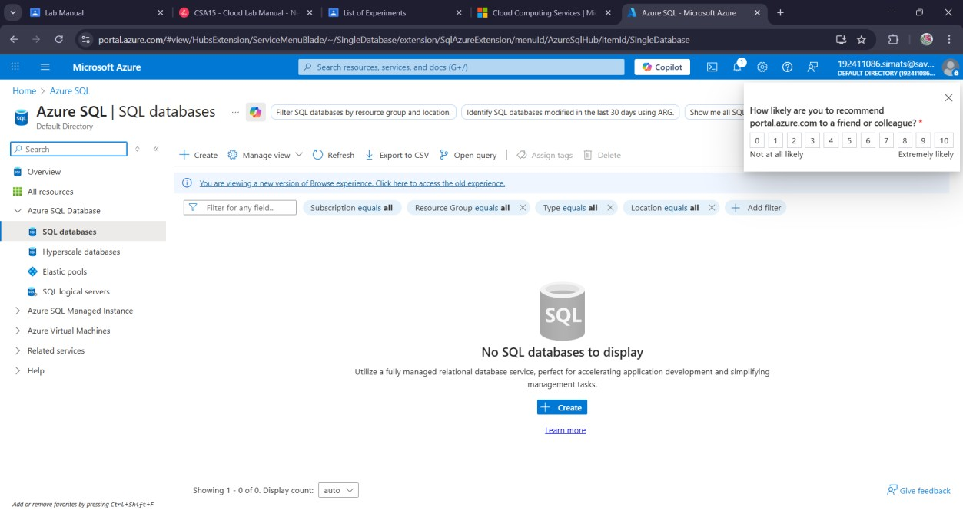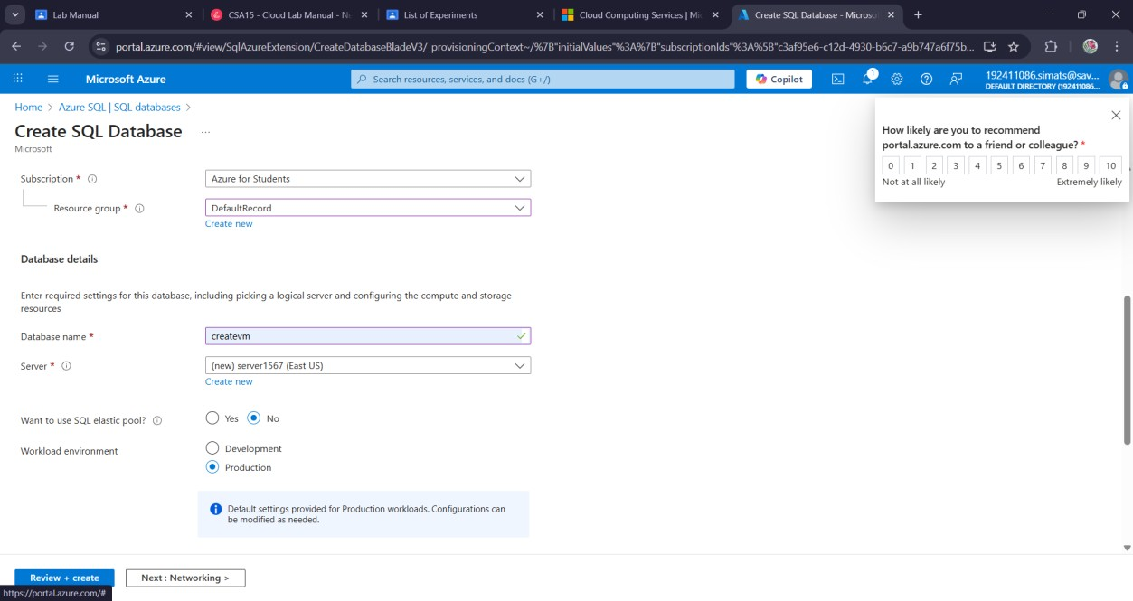

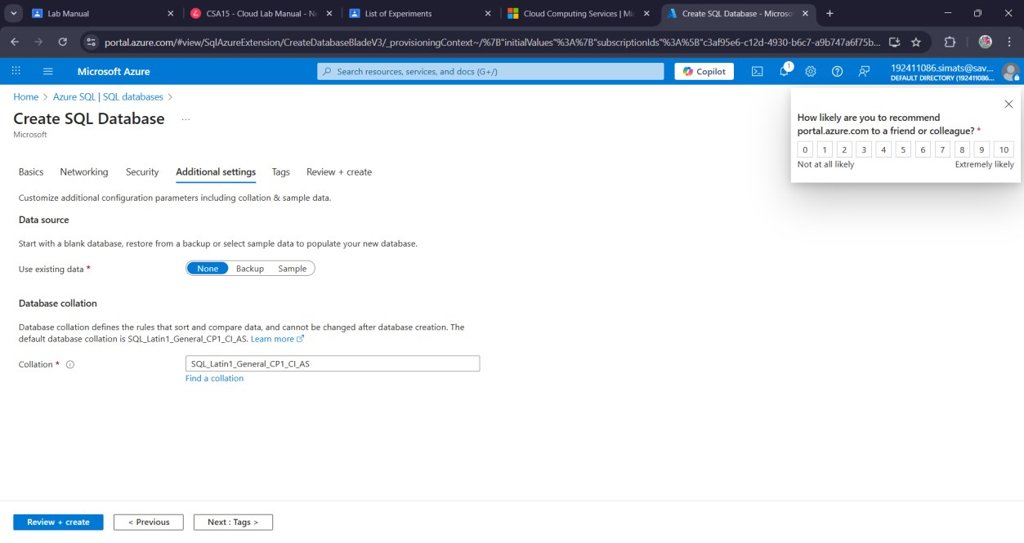

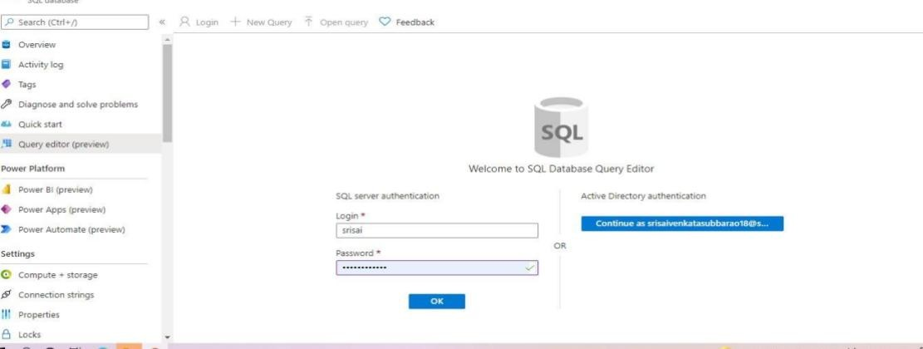

**Result:**

A service (daas) create and configure a new vm image in any public cloud service provider using azure has been created.